# Universitatea Tehnică a Moldovei

# Facultatea Calculatoare Informatică și Microelectronică

# Specialitatea Tehnologii Informaționale

# **RAPORT**

la lucrarea de laborator nr. 1

la Programarea Aplicatiilor Mobile

A efectuat: Palii Dan Grupa TI-203

A verificat: Stamatin Alexandru

XML:

<?xml version="1.0" encoding="utf-8"?>  
<androidx.constraintlayout.widget.ConstraintLayout xmlns:android="http://schemas.android.com/apk/res/android"  
 xmlns:app="http://schemas.android.com/apk/res-auto"  
 xmlns:tools="http://schemas.android.com/tools"  
 android:layout_width="match_parent"  
 android:layout_height="match_parent"  
 tools:context=".MainActivity">  
  
 <Button  
 android:id="@+id/calculate"  
 android:layout_width="wrap_content"  
 android:layout_height="wrap_content"  
 android:layout_marginStart="102dp"  
 android:layout_marginTop="251dp"  
 android:layout_marginEnd="103dp"  
 android:background="#B31818"  
 android:backgroundTint="#8E2323"  
 android:text="Enter Birthday Date"  
 app:layout_constraintEnd_toEndOf="parent"  
 app:layout_constraintStart_toStartOf="parent"  
 app:layout_constraintTop_toTopOf="parent"  
 app:strokeColor="#C82727"  
 tools:ignore="HardcodedText,MissingConstraints" />  
  
 <TextView  
 android:id="@+id/Age"  
 android:layout_width="0dp"  
 android:layout_height="20dp"  
 android:layout_marginStart="132dp"  
 android:layout_marginBottom="340dp"  
 app:layout_constraintBottom_toBottomOf="parent"  
 app:layout_constraintStart_toStartOf="parent"  
 tools:ignore="MissingConstraints" />  
  
</androidx.constraintlayout.widget.ConstraintLayout>

Kotlin:

package com.example.lab_1_pam  
  
import android.annotation.SuppressLint  
import android.app.DatePickerDialog  
import androidx.appcompat.app.AppCompatActivity  
import android.os.Bundle  
import android.view.View  
import android.widget.Button  
import android.widget.EditText  
import android.widget.TextView  
import android.widget.Toast  
import java.util.Calendar  
  
class MainActivity : AppCompatActivity() {  
  
  
 override fun onCreate(savedInstanceState: Bundle?) {  
 super.onCreate(savedInstanceState)  
 setContentView(R.layout.activity_main)  
  
 val calculate = findViewById<Button>(R.id.calculate)  
 calculate.setOnClickListener()**{**view**->**  
printAge(view)  
 **}**  
  
}  
  
 @SuppressLint("SuspiciousIndentation")  
 private fun printAge(view: View){  
 var myCalendar = Calendar.getInstance()  
 var year = myCalendar.get(Calendar.YEAR)  
 var month = myCalendar.get(Calendar.MONTH)  
 var day = myCalendar.get(Calendar.DAY_OF_MONTH)  
  
 DatePickerDialog(this,DatePickerDialog.OnDateSetListener**{**  
view,year,month,day**->**  
  
  
  
var dob = Calendar.getInstance()  
 dob.set(year,month,day)  
  
 var age = myCalendar.get(Calendar.YEAR) - dob.get(Calendar.YEAR)  
 if (myCalendar.get(Calendar.DAY_OF_YEAR) < dob.get(Calendar.DAY_OF_YEAR))  
 {  
 age--  
 }  
  
 var current_age = findViewById<TextView>(R.id.Age)  
 current_age.text = "You are $age year old"  
 **}**  
,year  
 ,month  
 ,day).show()  
  
 }  
}

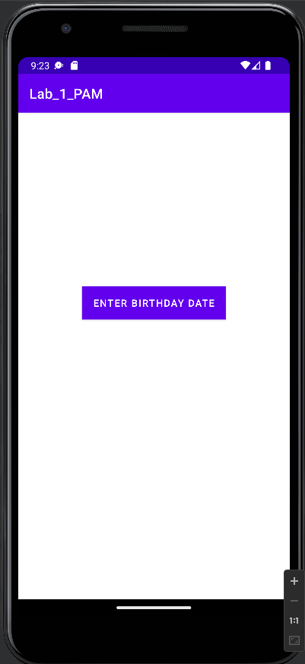

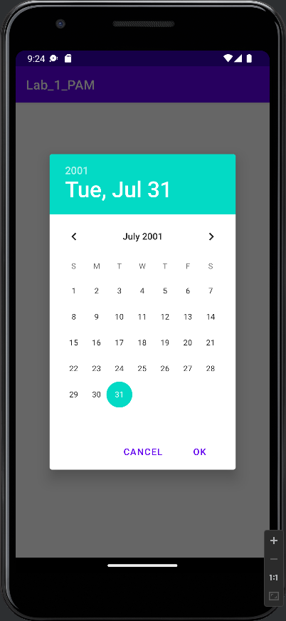

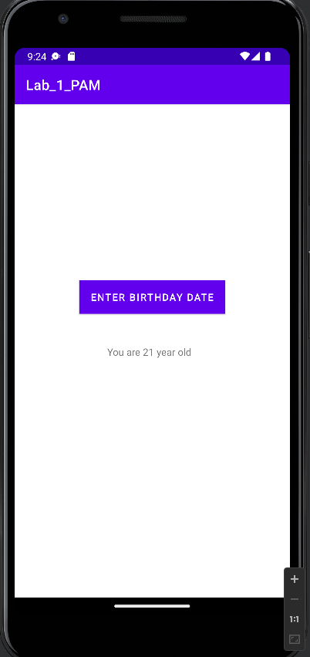

Concluzie

In aceasta lucrare de laborator am creat o aplicatie mobila ce calculeaza varsta curenta. Pentru a crea aceasta aplicatie am folosit Android Studio si ca limbaj de programare am folosit Kotlin.

val calculate = findViewById<Button>(R.id.calculate)  
 calculate.setOnClickListener()**{**view**->**  
printAge(view)

In aceasta sectiune care se afla in onCreate se afla functia ce actioneaza butonul si calculeaza varsta. private fun printAge(view: View){  
 var myCalendar = Calendar.getInstance()  
 var year = myCalendar.get(Calendar.YEAR)  
 var month = myCalendar.get(Calendar.MONTH)  
 var day = myCalendar.get(Calendar.DAY_OF_MONTH)

In aceasta sectiune am creat functia printAge, si am declarat variabilele pentru datele de introducere ca anul, luna, ziua, si data in intregime.

var age = myCalendar.get(Calendar.YEAR) - dob.get(Calendar.YEAR)  
 if (myCalendar.get(Calendar.DAY_OF_YEAR) < dob.get(Calendar.DAY_OF_YEAR))  
 {  
 age--  
 }

In aceasta secventa calculam varsta persoane care se afla dupa calcularea datei prezente care este salvata in variabila dob si data introdusa din myCalendar.

GitHub:

https://github.com/danpalii/lab_pam.git